Design Document

Imaging Navigator

**CS9033 Mobile Application Programming Fall 2015**

Xi Zhang: xz1226 N11901444

Xinli Wang: xw1036 N11267408;

Tao Kang: tk1693 N12842685

Version History

|  |  |  |
| --- | --- | --- |
| Version | Date | Modification Note |
| 1.0 | 9/30/2015 | Initial Design |
|  |  |  |

Content

1 Problem Overview and Introduction 3

2 Current Solutions and Related Work 4

3 Solution 5

3.1 Use Cases 5

3.2 Architecture Diagram 5

3.3 MVC Framework 5

3.4 UI Drawings 6

3.5 Other Android Components 6

4 Project Member Breakdowns 7

5 Goals for each Milestone 8

6 Bibliography 9

# Problem Overview and Introduction

According to survey from Global Web Index, it is shown that, up to 2015, the global popularity of using smartphone is 80%. And the report from comScore shown Android operating system has 53.2% usage share in U.S. up to January 2015 which is 10% higher than IOS, and according to data from other organizations, the usage share should be much higher in Asia and other areas.

As most of people carries a smart phone with their daily lives, a map or a navigator mobile application should be necessary to be installed in or being pre-installed in the mobile device. Comparing to the traditional map, the mobile navigator is easier to carry and more convenient to the find the path to the destination.

The Imaging Navigator is a mobile application that enables a driver or a walker to find the correct path to the destination no matter he or she is good at reading map or finding the direction. The Imaging Navigator application is mainly in two basic part: the traditional map navigator view and the camera based navigator view.

* The traditional map navigator view

It is based on the map, which shown the planed path. This view is also able to use as a normal GPS map. When setting a navigation path, it will provide path solutions with walk, drive or public transfers.

* The camera based navigator view

It is shown on the camera. The screen will show the real view which the camera is catching. When the navigation is started, there will be an arrow shown on the screen, and before the turning the arrow will be changed into a curved arrow. The arrow will be change the direction with the direction change of the device.

The traditional map navigator view is easy to get the destination and could have a more clear view of the full path. But, there is still some of the user could not or not good at reading the map, or there might be some people who might loss direction even when he is looking the map. As the main point of the Imaging Navigator application, the camera based navigator view could give these people a great help.

# Current Solutions and Related Work

There are many navigator applications in the market, some of them are wildly using in daily lives. Although the applications are beautiful and powerful, but none of them provide the function of the real view imaging navigation.

Here are some of the most popular navigator applications.

Google Maps

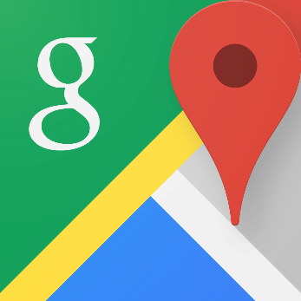The Google Maps app makes navigating your world faster and easier. Find the best spots in town and the information you need to get there. It is comprehensive, accurate maps in 220 countries and territories and has street view and indoor imagery for restaurants, museums, and more. But its arrow doesn’t often direct a way instantly. The general situation is when we try to walk a little way, we find we are going to the opposite direction. It bothers us a lot.

GPS Navigation & Maps Sygic:

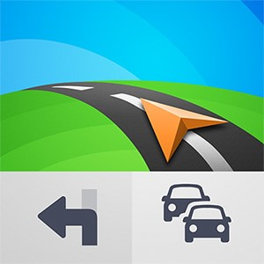GPS Navigation & Maps gets the most of the navigation, upgrade to premium and enjoy high-end lifetime features: 3D maps, real-time turn-by-turn voice-guided navigation, lane guidance, speed limit warnings & junction view with lane indicator arrows at complex intersections. But the problem is we need enough storage to store the offline map data information.

Waze

Waze is the world's largest community-based traffic and navigation app. Join other drivers in your area who share real-time traffic and road info, saving everyone time and gas money on their daily commute. However, it isn't really necessary for simple navigation. Commuters probably love the app, but we don't need an app doesn't have the nicest and smoothest interface to drive 20 minutes on Brooklyn.

# Solution

The Imaging Navigator is navigation application, and it is an online Google Maps API based navigator. So the Imaging Navigator will not provide the offline version navigational, and it must link the internet to initial some of the setting when it starts.

The Imaging Navigator is mainly organized into parts.

Firstly, as a navigator, a map view is typically basic and important. The map based view is basic on the Google Maps, so it allows all the functions that Google Maps have, which should include viewing the map, setting the destination point, stating the navigation, changing the preference way (drive, walk or public transportation) to the aim, resetting or restarting a new path and so on.

Secondary, the camera based view navigator, which is the main and most important part of the Imaging Navigator, is separated into the camera and the navigation arrow. The camera uses the device default camera to catch the actual view as the view of the navigator view. The other part if the navigator arrow. The Imaging Navigator did not calculate, analyze or compare the image data catch by the camera with the online stored real view data, the navigation arrow is created according to the data analyzed between the navigation paths in the API passed from the map view and the current lactation and the orientation of the mobile device.

## Use Cases

* Map View Based Navigator Screen

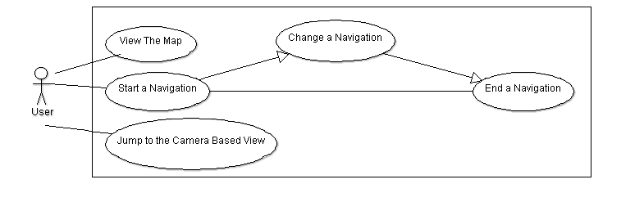

The map view based navigation screen is the initial screen when the application is started. In the map view based navigation screen, users are able to view the map, and create a new navigation at any time. When creating the path, the Imaging Navigator allows user to create by searching, clicking on the map and some other methods. When a navigation activity is created, it should be able to be modified or ended whenever the user want. At last, user could easily jump to the camera based navigation screen.

* Camera View Based Navigator Screen

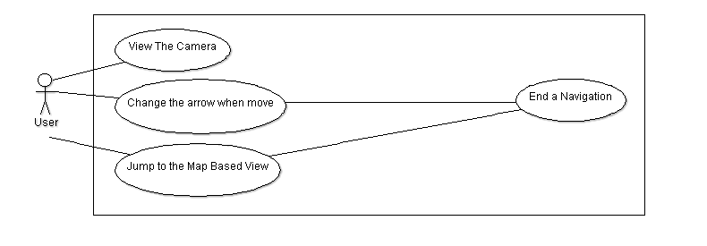

User could entered the camera view based navigation screen from the map based navigation screen. And the camera view based navigation screen shows an arrow to show the direction for the user which will always point to the correct way wherever the device is point to, and it enables the user to stop the navigation is started. But the modification and the initialization of the navigation is only allowed in the map view based navigation screen. At last, user could easily jump to the map based navigation screen.

## Architecture Diagram

**Imaging Navigator**

MainActivity

MapViewActivity

Navigation

CameraViewActivity

**Camera**

## MVC Framework

### Model

Navigation.java

The navigation is a model built when a user starts a new navigation. The model stores all the information of the navigation, which include the point the user is in, the path, and some warning information in the path. At the same time, the navigation should be running and always renewing the data in the model as it is a navigation application.

### Controller

MainActivity.java

The main activity of the Imaging Navigator. It is the first activity run when the application is started, and it will be automatically jump into the map view based navigation screen.

MapViewActivity.java

The map view activity of the Imaging Navigator. It supports the map view based navigation, and it allows and helps user to create, end and monitor the navigation.

CameraViewActivity.java

The camera view activity of the Imaging Navigator. It supports the camera view based navigation. It is linked to the camera of the device, and it is used to update and refresh the navigation allow time to time.

## UI Drawings

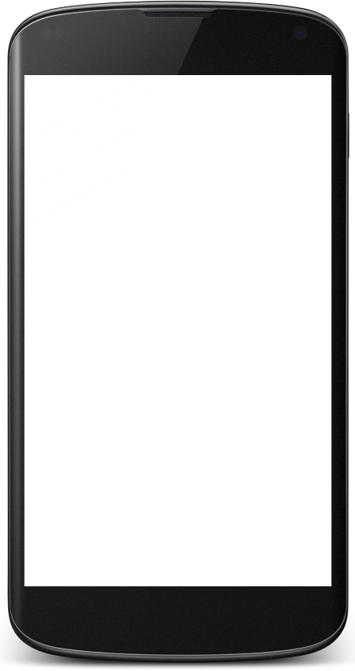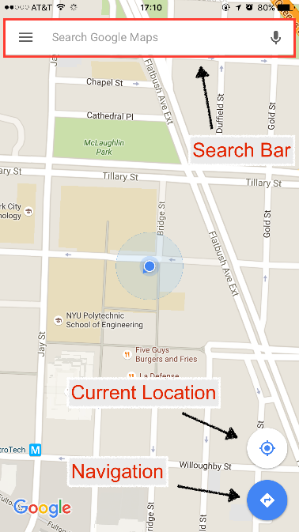

* Initial Activation

Search location via the search bar

Find current location

Search path between given two location

Navigate to the target position

* Search Path

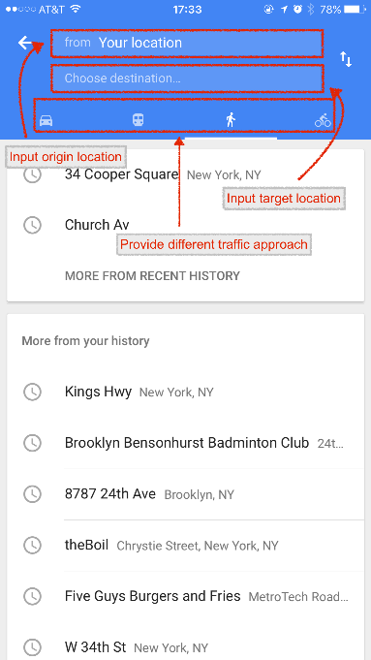

We can search path between given origin and target locations

User can input both locations via input text fields

Also can choice different traffic approach, time estimation will be different for different approaches

* Show Path

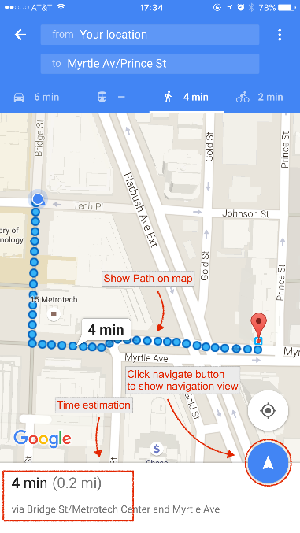

The app will calculate the primitive path and show it on map

Also will estimate arriving time based the traffic approach u ser select

Click navigate button will enter navigation view

* Map Navigation

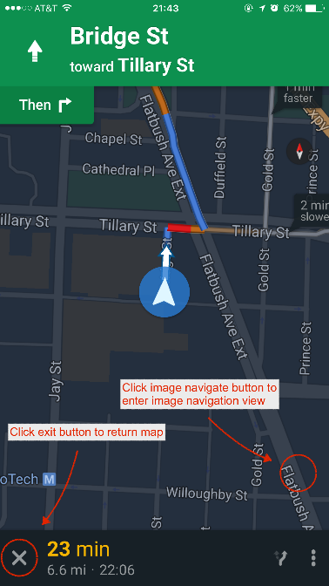

Navigation view will navigate user to corresponding location

User can exit this view via click exit button

User can also enter image navigation view via click image navigate button

* Image Navigation

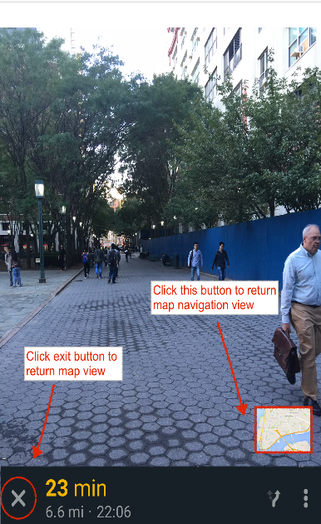

Will get live image via camera

Will show direction on the image view

Can return to map navigation view via clicking button on the right corner

Can return to map view via clicking the exit button on the left corner

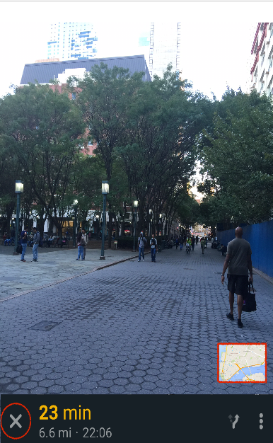

When the user facing the wrong direction, the image navigator will show the correct direction that user should heading for

You can see on the screen, the pointing arrow has leaned a little bit to point to the correct way

## Other Android Components

The Imaging Navigator is allowed to run in the background. As a navigator, the application will be enable to send alarm to the user, and it is implement by the android service.

# Project Member Breakdowns

As a three member project application, all the members should be greatly understand the whole application design and the programming.

Xi Zhang (Leader): Core Function Developer

Documentation

Reading and implementation the google maps API

Analyze the navigation data

Xinli Wang: Core Function Developer

Reading and implementation the google maps API

Analyze the navigation data

Tao Kang: Core Function Developer, UI Developer

Reading and implementation the google maps API

Camera implementation

Design the UI

# Goals for each Milestone

|  |  |
| --- | --- |
| Date | Modification Note |
| 10/2/2015 | Initial Design Document Start |
| 10/18/2015 | Basic UI Design Finish  Initial Design Document Due |
| 11/2/2015 | Initial Prototype Presentation |
| 11/15/2015 | Map View Navigator Design Finished |
| 11/30/2015 | Poster Presentation |
| 12/6/2015 | Application Almost Finished  Final Debug and Real Testing  Start Final Document |
| 12/14/2015 | Final demo |
| 12/20/2015 | Final Design Document Due |

# Bibliography

1. Global Web Index: *www.globalwebindex.net*
2. comScore Reports January 2015 U.S. Smartphone Subscriber Market Share: *http://www.comscore.com/Insights/Market-Rankings/comScore-Reports-January-2015-US-Smartphone-Subscriber-Market-Share*